NCP-005 Remote Sensor Platform

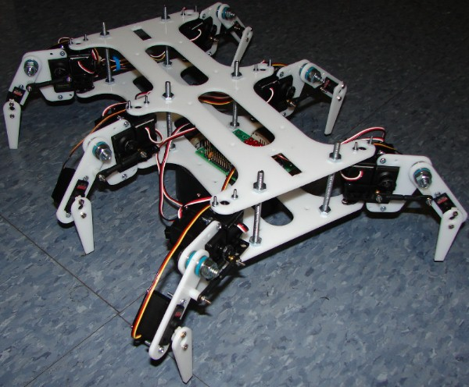
Figure A

Jason Hunt – nulluser@gmail.com
Andy Kuns – andy.kuns@gmail.com
Draft 1 – 7/13/2007

Table of contents
Section
1. Overview
2. Leg System
2.1 Inverse Kinematics
2.2. Four Bar Linkage
2.3 Leg torque calculations
3. Controller Boards
3.1 Motion controller board
3.2 Servo controller board
4. Communication
4.1 Motion controller communications
4.2 Servo controllers board communications
5. Embedded Linux System
6. Windows Host Software
7. Power system
8. Fabrication and parts

List of figures

Figure
A. Image of robot
1. Top and side view of leg
2. Side view of leg for Kinematics
3. Four Bar Linkage
4. Motion controller board
5. Servo controller board

List of Tables
Table
1. Motion controller board connections
2. Servo controller board connections
3. Parts List
1. Overview

This robot was designed as a remotely controlled platform for image and sensor data gathering. It communicates with a base planning station using WiFi and is capable of running in an unsupervised mode for extended periods of time. This document describes the electrical and mechanical systems in detail to facilitate modifications to the robot for specific applications.

2. Leg System

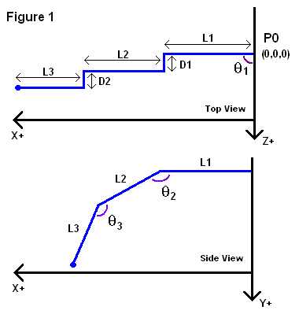
Each leg has three degrees of freedom, hip rotation (θ₁), hip lift (θ₂) and knee lift (θ₃). The hip joints are actuated with two Futaba S3004 servos. The knee joint has a lower torque requirement therefore a Hitec HS-81 was used. The link segments are directly attached to the servo with one exception. The hip lift servo is connected the link with a four bar linkage. L1-L3 and D1-D2 are physical parameters of the leg and are needed in the inverse kinematics and four bar linkage calculations.

The system uses four types of data to represent where the leg is in space.

1. Local Cartesian coordinates. Each leg has a separate local coordinate system with the origin placed at point P₀ in figure 1. The z axis increases while moving from the front of the robot to the back. The x axis is positive with increasing distances away from the center and the y axis increases downward.

2. Joint angles. θ₁ increase as the hip is rotated toward the front of the robot. The zero point is defined as when the leg is orthogonal to the robot base. The hip lift angle, θ_{2,} is zero when the leg is facing straight out. It increases to approximately 65 degrees when fully lowered. A conversion is used to change this desired leg angle into the correct servo angle. This takes place before the servo position is calculated. The knee lift angle is zero when the leg is fully extended and increases as the end effector is brought closer to the robot frame. The joint angles are converted to servo angles before the servo position is calculated.

3. Servo position. The servo position is stored internally as an unsigned character with range [0..255]. This represents approximately 180 degrees of motion. Servo angles are converted to servo positions by using the following formula: P = scale * angle + offset. Where P is the servo position, offset is a base offset and scale is a linear scaling factor. These constants must be calibrated to compensate for differences among servos.

4. Output pulse width. Standard radio control model servos use a pulse width as a position input. Typically the width ranges between 1ms and 2ms. The frequency of this pulse train is 50 Hz. The average torque output of a given servo will fall when the update frequency drops below this.

2.1 Inverse Kinematics
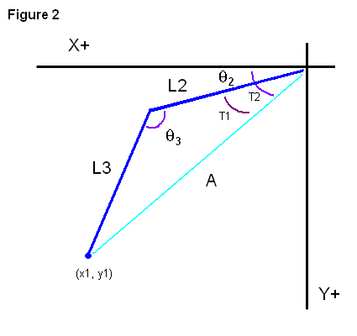
When the leg is orthogonal to the robot base, the end effector is offset from the origin in the z direction by d1+d2 (figure 1). This complicates solving for the hip rotation and leg lift angles. The hip angle will always be less then the expected atan(z1/ x1) because of this offset. This offset angle determines how much the hip rotation angle needs to be modified to position the end effector correctly.

First the distance from the origin to the end effector on the x-z plane is calculated,
$$d=\sqrt{x^{2}+y^{2}}$$

The offset (d1+d2) is a constant, so the required offset angle is:

$$\text{ofs}={\text{sin}}^{−1}\left(\frac{d_{1}+d_{2}}{d}\right)$$

Now we can compute the correct hip rotation angle:

$$θ_{1}={\text{tan}}^{−1}\left(\frac{z}{x}\right)−\text{ofs}$$

Next, the distance from the end effector to the end of link1 is calculated. The will allow the calculation of the local X-Y plane for the hip lift and knee lift angles.

The distance and leg offset are known, as is the length of the first link. Using these, the local x component is found:
$$x_{1}=d\text{*cos}\left(\text{ofs}\right)−l_{1}$$
The Y component of the requested end effector position remains unchanged and becomes y₁ for convenience.

After these rotations take place, the final two links and associated angles can be thought of as residing in their own X-Y plane. Let (x1, y1) be the end effector position in this plane. A line (A) is constructed from the origin to this point. Let t₂ be the angle between this line and the X-axis. t₁ is the angle between this line and link 2. Angle t₂ is straightforward to calculate using atan2.

$$t_{2}={\text{tan}}^{−1}\left(\frac{y_{1}}{x_{1}}\right)$$

This result is range check to make sure the requested angle is physically possible.

t₁ is calculated using the law of cosines. This is the general form for the triangle in question:
$$l_{3^{2}}=a^{2}+l_{2^{2}}−2{\text{al}}_{2}\text{cos}t_{1}$$

Solving for t₁:
$$t_{1}={\text{cos}}^{−1}\left(\frac{l_{2^{2}}−l_{3^{2}}+a^{2}}{2{\text{al}}_{2}}\right)$$

Using t₁ and t₂, the hip lift angle is simply:
$$θ_{2}=t_{1}−t_{2}$$

Similar logic is used for the knee lift angle. Here is the general form again relating knee lift to the links:
$$a^{2}=l_{3^{2}}+l_{2^{2}}−2l_{2}l_{3}\text{cos}(\text{180}−θ_{3})$$

Solving for θ₃:
$$θ_{3}=\text{180}−{\text{cos}}^{−1}\left(\frac{l_{3^{2}}+l_{2^{2}}−a^{2}}{2l_{2}l_{3}}\right)$$
Subtracting from 180 degrees is necessary because the fully extended configuration is zero degrees, not 180 as would be expected.

Now all three joint angles are known. The hip rotation and knew lift angles can be directly related to servo positions. The hip lift angle need additional conversion because of the four bar linkage.

2.2. Four Bar Linkage
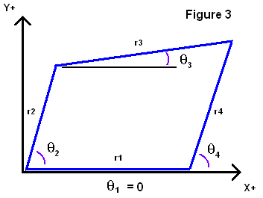
The hip lift servo is connected to the knee joint using a four bar linkage. This allows the hip to have a home position that requires very little torque from the servo to maintain. The four bar linkage problems reduces to this question: What servo angle is needed for the desired joint angle?

In figure three, r₁ is the distance between the center of the servo output and the hip pivot point. r₂ is the distance between the hip pivot and the point where the linkage connected to the hip link. r₃ is the length of the linage and r₄ is the radius of the servo arm. θ₁ to θ₄ are local and should not be confused with the leg joint angles.

Treating r₁-r₄ as vectors the following link closure equation is defined:
$$\vec{r_{2}}+\vec{r_{3}}=\vec{r_{1}}+\vec{r_{4}}$$
.
Separating horizontal and vertical components yields:
$$r_{2}\text{cos}θ_{2}+r_{3}\text{cos}θ_{3}=r_{1}\text{cos}θ_{1}+r_{4}\text{cos}θ_{4}$$
$$r_{2}\text{sin}θ_{2}+r_{3}\text{sin}θ_{3}=r_{1}\text{sin}θ_{1}+r_{4}\text{sin}θ_{4}$$

The constants are grouped into a reference point
$$\text{tx}=r_{1}\text{cos}θ_{1}−r\text{*cos}θ_{2}$$
$$\text{ty}=r_{1}\text{sin}θ_{1}−r\text{*sin}θ_{2}$$
With length
$$l=\sqrt{{\text{tx}}^{2}+{\text{ty}}^{2}}$$

This leaves
$$r_{3}\text{cos}θ_{3}−r_{4}\text{cos}θ_{4}=\text{tx}$$
$$r_{3}\text{sin}θ_{3}−r_{4}\text{sin}θ_{4}=\text{ty}$$

Solving for θ₄ while discarding θ₃:

$$θ_{4}=\text{180}−{\text{tan}}^{−1}\left(\frac{\text{ty}}{\text{tx}}\right)−{\text{cos}}^{−1}\left(\frac{l^{2}+r_{4^{2}}+r_{3^{2}}}{2{\text{lr}}_{4}}\right)$$

Again, the subtraction from 180 is needed to wrap the angle back around. This local θ₄ is actually the θ₂ needed for the hip lift servo angle.

2.3 Leg torque calculations

None yet.

3. Controller boards
Two printed circuit boards were custom fabricated for this project because no commercially available boards fit the unique timing and redundancy requirements of the system. The boards were designed in Eagle Cad and fabricated by pcbfabexpress.com for a reasonable price.

3.1 Motion controller board

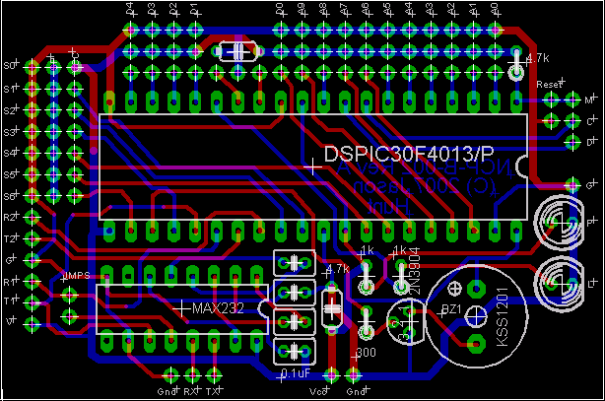
Figure 4

The motion controller uses a dsPIC microcontroller. Its main purpose is to interface the servo controllers to the gumstix computer. This specific controller was selected because it contains two UARTs, O0ne is used to connect to the linux computer and the other is used to communicate with the serial ring that contains the servo controllers.

Table 1
A0-A9 | Analog inputs
D0-D4 | Digital I/O
S1-S6 | Servo Outputs
S0 | Power selection for servo system
R2 | TTL Level serial receive
T2 | TTL Level serial transmit
R1 | Same signal as Rx, TTL level
T2 | Same signal as Tx, TTL level
RX | RS232 Port receive to gumstix
TX | RS232 Port transmit to gumstix
M | MCLR
C | Program Clock
D | Program Data

3.2. Servo controller board

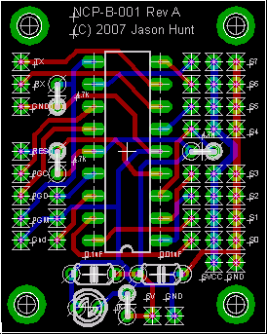
Figure 5

Four servo/analog controller boards communicate with each other and the motion controller board using a serial ring. Three are used for leg control and one is used for the forward/reverse gimbal platforms. Each leg board is responsible for six servo PWM outputs and two analog inputs connection to the foot pressure sensors. The gimbal board controls the servos that position the IR sensors and camera. It also sample the analog data fro the IR sensors.
S0-S5 | Servo Outputs
S6-S7 | Analog Inputs
SVcc | Servo Port
Res | MCLR
PGD | Program Data
PGC | Program Clock
PMG | Low voltage programming input
Tx | Connects to SynRx on motion board
Rx | Connects to Tx on motion board
5V | 5 Volt supply
Gnd | Board ground

4. Communication
An onboard computer capable of running linux interfaces with a host control station via WiFi and to a local controller board via serial. The controller board coordinates the servo controllers and distributes the servo positions. It is also responsible for packaging the analog telemetry information. The servo controllers need to output an accurate pulse train to all six servos simultaneously. Interrupts for serial receive can not be used because the interrupt might occur too close to the PWM output transition. If this happens, the pulse width of the servo PWM signal will be extended causing the servo to glitch. To fix this problem, a serial interface protocol was designed that does not rely on interrupts.

4.1 Motion controller communications
Two I/O channels of the motion controller board are utilized for this communication interface. Tx is an output and sends data directly to all four servo controllers. SynRx is bidirectional and is used to sync packets and receive analog data.

Set CurrentDevice to 0
Set SynRx as an output

TransferData:
// Send phase
Set SynRx high
Wait a set amount for servo board to get into receive loop
Send CurrentDevice number
Send all six servo positions for the current device
Set SynRx low

// Receive phase
Wait for response packet on SynRx pin
Receive and store analog 0 data
Receive and store analog 1 data
Receive and store high analog bits

// Housekeeping
Increment CurrentDevice
If (CurrentDevice > number of devices)
Set CurrentDevice to 0

Set SynRx as an output
Set SynRx low
Wait for boards to catch up

Jump to TransferData

This pseudocode is not entirely accurate because this code is implemented using interrupts on the actual board.

4.2 Servo controllers board communications

Set TX as an input
ServoMain:

// Servo timing

// This can take anywhere from 6 to 12 milliseconds
for (int i = 0; i < 6; i++)
Set servo_output[i] high
Wait base_offser delay
Wait servo_positon[i]
Set servo_output[i] low

// Communications
Wait for Tx to go high

Receive DeviceID
Receive Servo Positions
If the device ID is the same as the board,
Copy data to local servo positions
Set Tx as an output

Send analog 0
Send analog 1
Send high analog bits
Set Tx as an input

Jump to ServoMain

At a servo update rate of 50Hz, there is a 20ms time windows to perform the communication and servo update. A maximum of 12 ms can be used by the servo timing code. This leaves a minimum of 8ms available for serial transfer. At 115200 baud, 87uS per byte is needed when the UART is configured for 8 data bits, one stop bit and no parity. With 10 bytes per board 40 bytes are needed total which takes 3.48 ms < 8ms, well with the time constraints.

5. Embedded Linux System
This computer is where the motion planning and leg kinematics calculations take place.

6. Windows Host Software
The software is used to setup high-level goals and monitor the video and sensor data coming back from the robot. The computer can be located anywhere as long as both it and the robot have an internet connection available. Video frame rate and sensor data capture rate will decline as more and more router are inserted between the robot and the host. For this reason is it preferable to connect the host to the robot using an ad-hoc WiFi network with no other devices using on the communications channel.

7. Power system
The main power source in untethered operation is two 5-cell NiMH battery packs wired in parallel. One 5V DC-DC converter is used to power the motion and servo controllers, and another is used to power the gumstix linux computer. The servos take their power directly from the battery packs which produce 6.0 volts when fully charged. Three toggles switches are provided to establish independent control of three power systems. The first power system consists of the gumstix computer, WiFi dongle and the webcam. The second system powers the motion controller board and the servo controller boards. The final system consists of the servos.

8. Fabrication
The robot was designed and modeled in SolidWorks.

Table 3 – Parts list

Part | Supplier | Quantity | Cost | Extended Cost
Plastic Fabrication | Architectural Vision | 1 | 30.00 | 30.00
gumstix verdex XL6P | Gumstix.com | 1 | 169.00 | 169.00
console-vx | Gumstix.com | 1 | 25.00 | 25.00
serial null-modem cable | Gumstix.com | 1 | 12.00 | 12.00
5.0 volt power adapter | Gumstix.com | 1 | 10.00 | 10.00
USB Gender Changer | Gumstix.com |  | 8.00 | 8.00
Servos
Futaba S3004 Servo | Tower Hobbies | 12 | 12.54 | 150.38
Hitec HS-81 Servo | Tower Hobbies | 6 | 15.66 | 93.94
PCB
Board fabrication | Pcbfabexpress.com | 2 | 78 | 156.00
DSPIC30F4013-30I/P | Newark | 1 | 5.86 | 5.86
PIC16F628A-E/P | Microchip | 5 | 1.85 | 9.30
5-Cell Battery |  | 2 | 30.00 | 60.00
¼ inch Thrust Washer | Jameco | 20 | 2.72 | 54.40
Servo hinge | Jameco | 10 | 3.47 | 34.70
Miscellaneous |  |  |  | 200.00
 |  |  | Total | 1018.58

